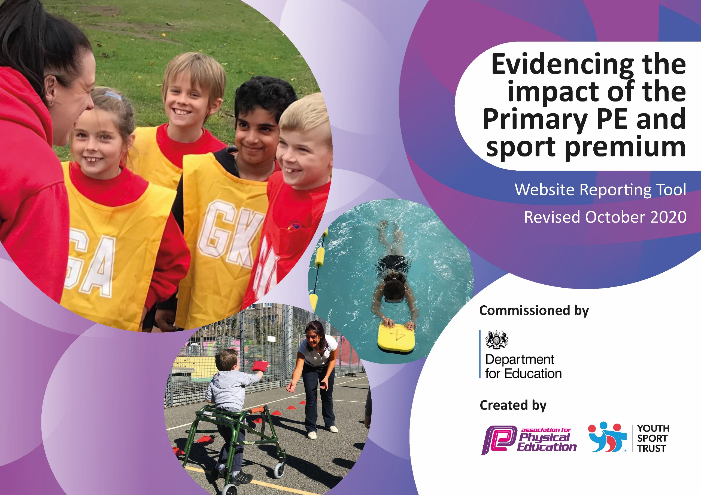

.
Review and Reflection - considering the 5 key indicators from DfE, what development needs are a priority for our setting and our pupils now and why?

Key achievements to date until July 2020: | Areas for further improvement and baseline evidence of need:
High percentage participation in subsidised extra-curricular clubs  Improved teacher confidence in delivering high quality PE teaching  Opportunities provided to try different activities  Children have had cross curricular sporting opportunities that have linked with literacy, citizenship, road safety and mental well being | Encourage greater participation by less active and pupil premium children as evidenced by data collected from club registers  When covid restrictions allow – further monitoring of lessons will be required  Identify pathways for children to pursue PE activities further by developing more ties with external clubs  Give more children across school opportunities to access successful activities

Did you carry forward an underspend from 2019-20 academic year into the current academic year? YES

If any funding from the academic year 2019/20 has been carried over you MUST complete the following section.
Academic Year: September 2020 to March 2021 | Total fund carried over: £5824 | Date Updated:  March 2021
What Key indicator(s) are you going to focus on?
The engagement of pupils in regular physical activity
 |  |  |  | £5824
Intent | Implementation |  | Impact
Engagement of children in regular physical activity  Increase confidence of staff delivering PE by purchase of equipment | Purchase of scooter park for KS1 yard  Investment in playground gym equipment -purchase and installation  Playground markings for Daily mile in KS1  Skipping ropes for school skipathon  Golf Starter class set | £899  £3540  £735  £300  £350 | Promote active schools.  Monitor via survey of how children are coming to school  Encourage active break times  Encourage active breaks in the school day and active break times  Each child had a skipping rope to use at school and home for skipathon week and for use after in breaks  Enable class teachers to deliver this socially distant PE activity | One off capital expenditure on these resources

Meeting national curriculum requirements for swimming and water safety.

N.B Complete this section to your best ability. For example, you might have practised safe self-rescue techniques on dry land.
What percentage of your current Year 6 cohort swim competently, confidently and proficiently over a distance of at least 25 metres?  N.B. Even though your pupils may swim in another year please report on their attainment on leaving primary school at the end of the summer term 2021. | 77 %
What percentage of your current Year 6 cohort use a range of strokes effectively [for example, front crawl, backstroke and breaststroke]? | 65 %
What percentage of your current Year 6 cohort perform safe self-rescue in different water-based situations? | 65 %
Schools can choose to use the Primary PE and sport premium to provide additional provision for swimming but this must be for activity over and above the national curriculum requirements. Have you used it in this way? | No  We already send children in Y3 and Y4 if they do not pass NC requirements first time

Action Plan and Budget Tracking
Intended annual spend against the 5 key indicators.

Academic Year: 2020/21 | Total fund allocated: £17500 | Date Updated: March 2021
Key indicator 1: The engagement of all pupils in regular physical activity – Chief Medical Officers guidelines recommend that primary school pupils undertake at least 30 minutes of physical activity a day in school |  |  |  | Percentage of total allocation:
 |  |  |  | 38 %
Intent | Implementation |  | Impact | Sustainability
Children have active break times | Extra – curricular clubs | £4100 | 26 clubs offered this year  (Less after school but more lunchtime activities) | Monitor attendance – particularly pupil premium and least active children
Children have active breaks between lessons | Purchase of Imoves subscription | £899 | Children keep active throughout the day with a variety of extra-curricular active breaks – including wellness and mindfulness breaks | Monitor via class ‘heat maps’
Key indicator 2: The profile of PESSPA being raised across the school as a tool for whole school improvement |  |  |  | Percentage of total allocation:
 |  |  |  | 11 %
Intent | Implementation |  | Impact | Sustainability
Improve ‘wellness’ and mental health of children | Worry Warriors programme | £600 | 12 children have taken part in the programme to date, with activities planned for a further 12 before the end of school year | Effectiveness has been monitored via pupil questionnaires
SUFC Healthy minds and bodies | Programme for upper KS2 children looking at healthy eating and sport | £360 | Health survey before and after course | Link with Science curriculum
SWFC Premier All Stars  Reading challenge  World Book Day Event  Show Racism the Red Card event  World Maths Day event | Encourage reluctant readers through SWFC delivery of this programme  PSHE curriculum links  Link to engagement in maths | Worked out as % of the SWFC package  £600 | Events that link sports with other curriculum areas have been popular. | Monitor the effectiveness of the reading intervention with targeted pupils

Key indicator 3: Increased confidence, knowledge and skills of all staff in teaching PE and sport |  |  |  | Percentage of total allocation:
 |  |  |  | 29 %
Intent | Implementation |  | Impact | Sustainability
Maintain high standard of PE teaching through use of specialist coaches for team teaching. | SWFC Premier All - Stars | £2690  (Worked out as % of the SWFC package) | All teachers in school have benefitted from working with specialist coaches – they team teach with support from the coach. | Teachers are adapting planning and resources – they are using techniques and tips picked up from specialist coaches to improve practice
Improve knowledge and skills of staff through use of high quality teaching resources | GetSet4PE – teaching, planning and assessment resource  Real PE – teaching resource for PE fundamentals | £550 per annum  £1375 three year subscription purchased  £299 | Staff audit has shown that teacher confidence has grown in delivering all aspects of PE curriculum  Staff are using resource to also deliver a wider variety of PE topics
Key indicator 4: Broader experience of a range of sports and activities offered to all pupils |  |  |  | Percentage of total allocation:
 |  |  |  | 7 %
Intent | Implementation |  | Impact | Sustainability
Deliver a variety of after school extra -curricular clubs  Themed activity days | Kicks Multi-sport clubs for KS1 and KS2 are subsidised to encourage participation  African Dance Day to celebrate Black History Month  Irish Dance Day – St Patrick’s day celebration | See also indicator 1 | Enthusiastic participation from children – signpost enthusiastic children and tell them of opportunities to continue out of school | Clubs have been impacted by COVID and will need to monitored when we can have a full programme of activities and more visitors to come into school

Key indicator 5: Increased participation in competitive sport |  |  |  | Percentage of total allocation:
 |  |  |  | 14 %
Intent | Implementation |  | Impact | Sustainability
 |  | Funding |  | Sustainability and suggested
Funding has been allocated towards membership of LINKS school sport partnership | Due to Covid restrictions there has been limited competitive sport | Allocated:  £1301 | Links have provide online support for teaching sporting activities and maintaining links between schools for future competitions  Facilitated loan of rowing machines for intra-school competition | next steps:  Funding has been reserved for Summer term for potential competitive activities
Travel to sporting events and supply cover costs for extra staff | Although allocated – not spent yet | £1000 | (Allocated for spend later in academic year if possible)

Signed off by
Head Teacher: | Matt Gaughan
Date: | 29/3/21
Subject Leader: | Nigel Hartley
Date: | 25/3/21
Governor: | Sue Brookes (Governing Board Chairperson)
Date: | 31 March 2021

