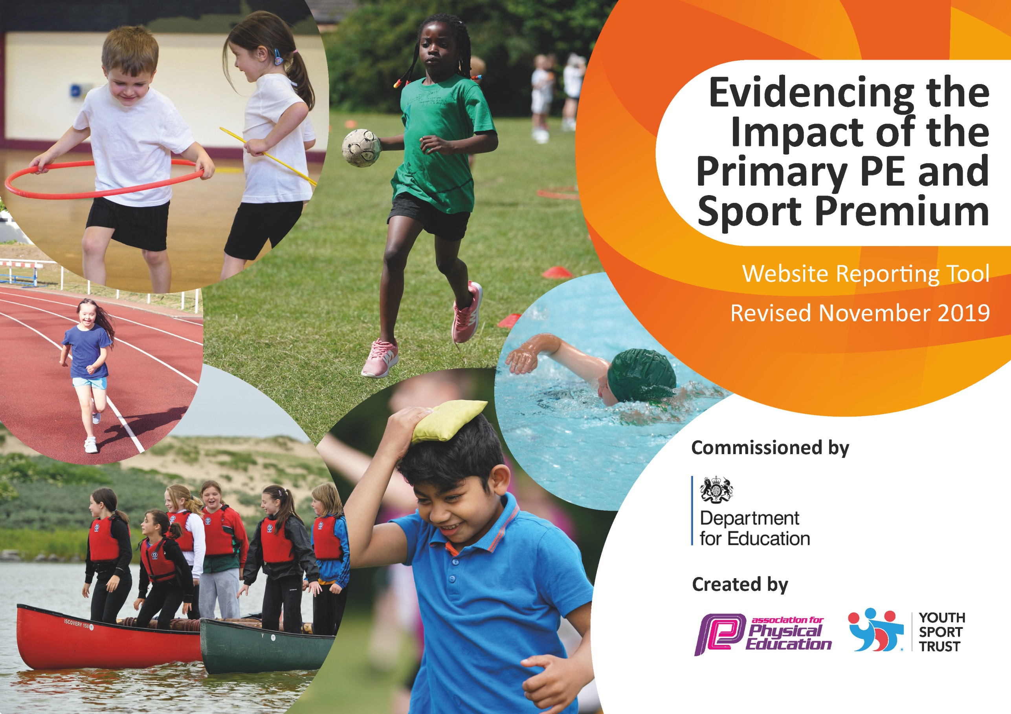
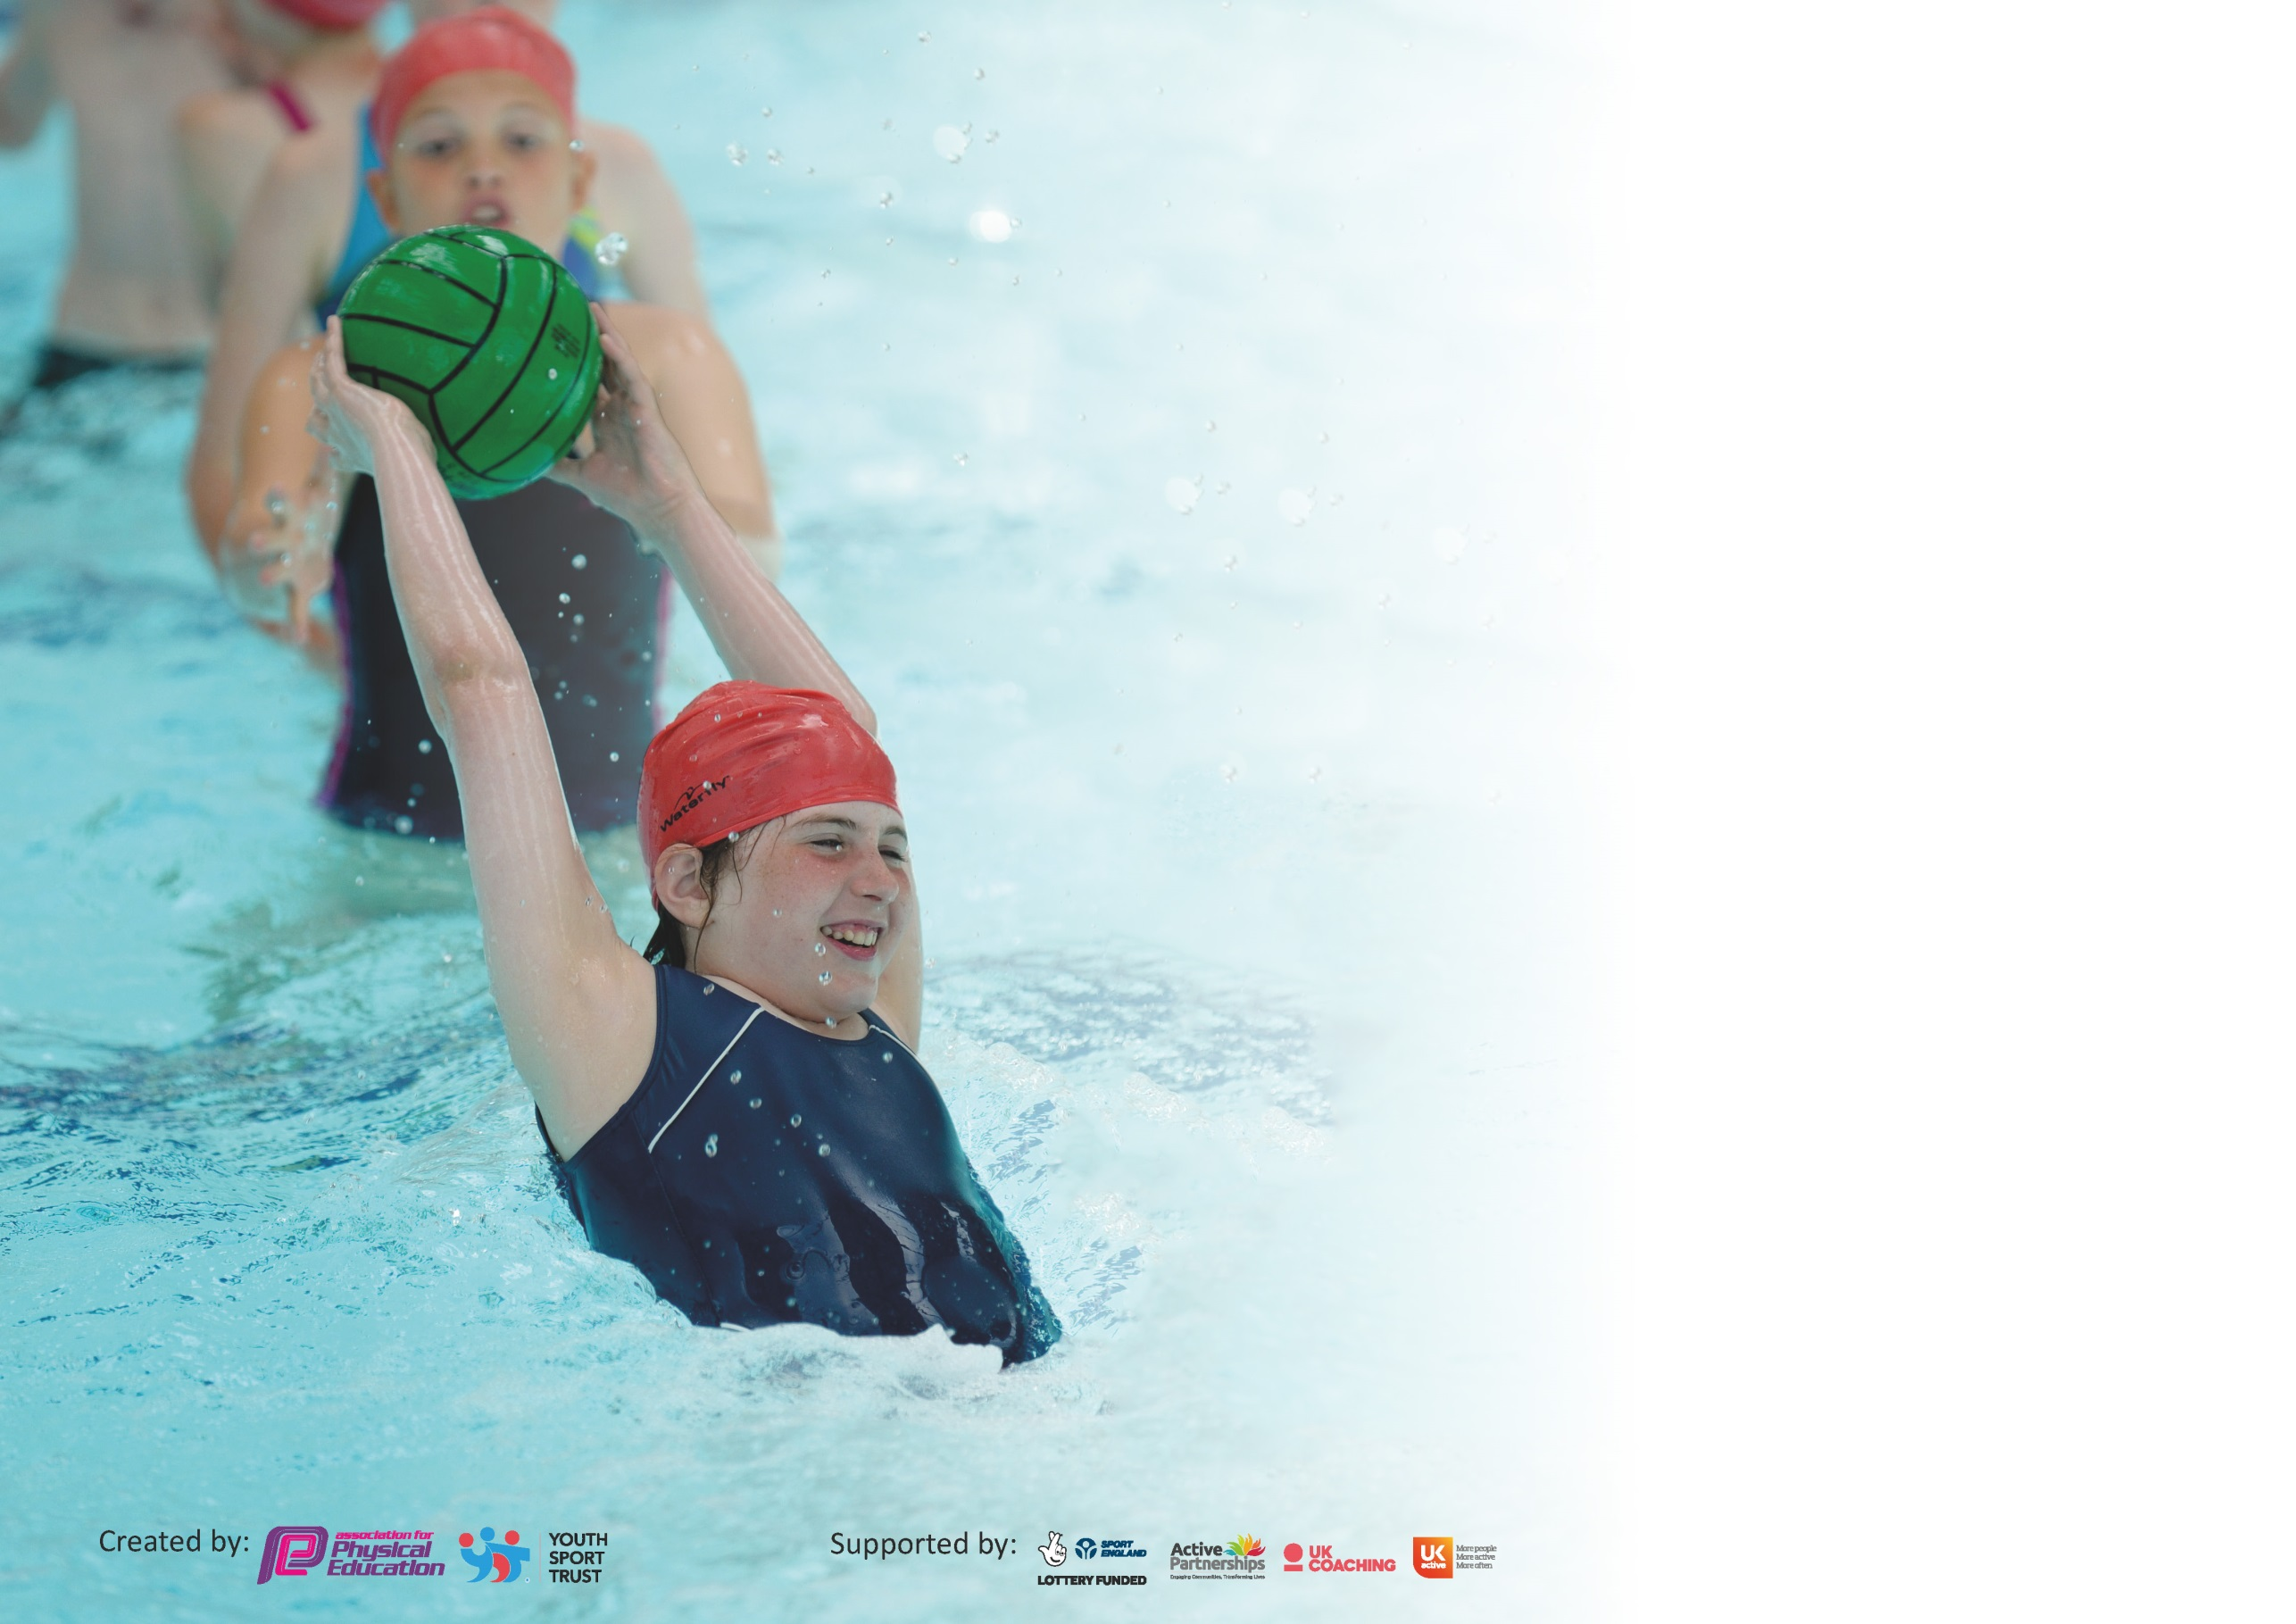

At Wharncliffe Side School we believe PE & Sport plays an important role in making our vision statement a reality for every pupil, with the potential to change young people's lives for the better.

We have welcomed the Government's additional funding to improve provision of physical education (PE) and sport in primary schools. We are committed to using this resource in developing high quality PE lessons, alongside greater opportunities for sporting competitions and clubs for all our young people.
Our aim is to encourage children of all abilities to have a more active lifestyle – in line with the government’s recommendations of 60 ‘active’ minutes a day. Every child should have the opportunity to represent school at a sporting event, every child should be given the chance try a new sport, every child should be given the chance to excel.

.

Support for review and reflection - considering the 5 key indicators from DfE, what development needs are a priority for your setting and your pupils now and why? Use the space below to reflect on previous spend and key achievements and areas for development.

Key achievements to date until July 2019: | Areas for further improvement and baseline evidence of need:
Children have opportunity for active breaks during school day  PE/ Sport/ Health / Well Being is being used to support other curriculum areas  Mindfulness fitness programmes popular with children and they have put techniques into practice in other curriculum areas  Healthy Eating knowledge increased  We have well resourced and well delivered PE lessons  Participation levels are high for clubs and competitions – but monitored to check who is least active  Our children are enjoying competitive sport | Engagement of least active children in particular SEND and pupil premium children  Increased competitiveness  Increased participation across school of mindfulness activities

Meeting national curriculum requirements for swimming and water safety.
What percentage of your current Year 6 cohort swim competently, confidently and proficiently over a distance of at least 25 metres?  N.B. Even though your pupils may swim in another year please report on their attainment on leaving  primary school at the end of the summer term 2020. | 85 %
What percentage of your current Year 6 cohort use a range of strokes effectively [for example, front crawl, backstroke and breaststroke]? | 85 %
What percentage of your current Year 6 cohort perform safe self-rescue in different water-based situations? | 74 %
Schools can choose to use the Primary PE and Sport Premium to provide additional provision for swimming but this must be for activity over and above the national curriculum requirements. Have you used it in this way? | No

Action Plan and Budget Tracking
Capture your intended annual spend against the 5 key indicators. Clarify the success criteria and evidence of impact that you intend to measure to evaluate for pupils today and for the future.

Academic Year: 2019/20 | Total fund allocated: £ | Date Updated:
Key indicator 1: The engagement of all pupils in regular physical activity – Chief Medical Officer guidelines recommend that primary school pupils undertake at least 30 minutes of physical activity a day in school |  |  |  | Percentage of total allocation:
 |  |  |  | 12 %
Intent | Implementation |  | Impact
Your school focus should be clear what you want the pupils to know and be able to do and about  what they need to learn and to  consolidate through practice: | Make sure your actions to achieve are linked to your intentions: | Funding allocated: | Evidence of impact: what do pupils now know and what can they now do? What has changed?: | Sustainability and suggested next steps:
The engagement of all pupils in regular physical activity – Chief Medical Officer guidelines recommend that primary school children undertake at least 30 minutes of physical activity a day in school | All classes have at least 2hrs per week PE  GONOODLE – free online resource to encourage active breaks  IMoves  KS2 – Ten Minute Run | Imoves subscription  £900 | Children have completed the Koboka school survey.  We do see ourselves as a ‘sporty’ school. Pupil voice forums are really positive with children enjoying PE lessons, seeing the importance of PE and enjoying the range of activities they are able to participate in.  KS2 children have been using this regularly for short brain break activities – teachers think that this is improving concentration levels  Used to supplement learning in other curriculum areas – need to reappraise and evaluate if there are enough activities and that it is being used regularly enough.  All 3 classes in KS2 try and complete ten minute runs regularly (3 times a week)  Children are enthusiastic and this is another way to offer a kinaesthetic brain break to afternoon sessions | Continue subscription to Imoves and ensure used throughout school  Encourage a KS1 version of Daily Mile in lower school
Key indicator 2: The profile of PESSPA being raised across the school as a tool for whole school improvement |  |  |  | Percentage of total allocation:
 |  |  |  | 27 %
Intent | Implementation |  | Impact
Your school focus should be clear what you want the pupils to know and be able to do and about  what they need to learn and to  consolidate through practice: | Make sure your actions to achieve are linked to your intentions: | Funding allocated: | Evidence of impact: what do pupils now know and what can they now do? What has changed?: | Sustainability and suggested next steps:
The profile of PE and sport being raised across the school as a tool for whole school improvement | Flower 125  (Self esteem / Healthy minds and bodies program)  Worry Warriors Yoga  Aimed at Y6 children  Premier All-Stars Reading Challenge  (Targeting reluctant readers in Y5/6 in particular)  SWFC Racism/ Diversity workshops  Lunchtime clubs  (target least active/ SEN who don’t come after school)  SEND  (Participation in competition)  Bikeability / Dr Bike – road safety  Nuffield Health / SUFC – Healthy eating  Active maths | £50 per session  Premier AllStars Programme  £2500 in total  (Half allocated to this area and half to CPD)  Premier Allstars  LINKS subscription  £1325  £360  £645  Subscription | All children in UKS2 have had chance to complete Flower 125 at least once. This program is always very popular with children.  Very popular with children – assessments from children have been very positive. Children have said they would recommend to other children and they have been putting techniques into practice  Potential to deliver to all Y6 before SATs  Increased enthusiasm for reading linked to a sporting theme  Attended by Y5/6 pupils at Hillsborough stadium. Delivery of key PSHE ideas through the medium of sport and supported by players was really popular with children  More work required to encourage least active children – will work better in summer months when can use field  SENCO has enthusiastically encouraged participation in competition as an opportunity to give children wider experiences of the world  Give children opportunity to ride on roads safely.Chance also to learn to ride and have bike safety checks.  Foundation stage have balance bikes that they use with younger children  Children in Y6 completed healthy eating and activity surveys before and after – their knowledge had increased  Using PE activities in Y1 to link to Maths games | Continue with successful clubs but encourage a broader take up though subsidising SEND and pupil premium places  Increase the number of Worry Warrior places to ensure that all Y6 get access this year  Evaluate success with potential or using in further year groups

Key indicator 3: Increased confidence, knowledge and skills of all staff in teaching PE and sport |  |  |  | Percentage of total allocation:
 |  |  |  | 18 %
Intent | Implementation |  | Impact
Your school focus should be clear | Make sure your actions to | Funding | Evidence of impact: what do | Sustainability and suggested
what you want the pupils to know | achieve are linked to your | allocated: | pupils now know and what | next steps:
and be able to do and about | intentions: |  | can they now do? What has
what they need to learn and to |  |  | changed?:
consolidate through practice:
Increased confidence, knowledge and skills of all staff in teaching PE and sport. | CPD  Coaches in school (SWFC/ LINKS)  Planning and teaching resources  Getset4pe  Real PE  Active Maths | £1500 | Teaching and learning in PE lessons is of a consistently high standard.  Lessons are well resourced and planned with links to previous learning and opportunities to develop skills | Continue to survey staff needs and confidence in delivering PE lessons.  Lesson monitoring to ensure coaching, teaching and club sessions are of a high standard
Key indicator 4: Broader experience of a range of sports and activities offered to all pupils |  |  |  | Percentage of total allocation:
 |  |  |  | 30 %
Intent | Implementation |  | Impact
Your school focus should be clear | Make sure your actions to | Funding | Evidence of impact: what do | Sustainability and suggested
what you want the pupils to know | achieve are linked to your | allocated: | pupils now know and what | next steps:
and be able to do and about | intentions: |  | can they now do? What has
what they need to learn and to |  |  | changed?:
consolidate through practice:
Broader experience of a range of sports and activities offered to all pupils. | After school clubs (target pupil premium)  Clubs are subsidised  ‘Day of’ sports | £4850 | Monitored via registers  e.g. Judo day | Offer children more ‘gateway’ opportunities to take sports to the next level through links to local clubs

Key indicator 5: Increased participation in competitive sport |  |  |  | Percentage of total allocation:
 |  |  |  | 13 %
Intent | Implementation |  | Impact
Your school focus should be clear | Make sure your actions to | Funding | Evidence of impact: what do | Sustainability and suggested
what you want the pupils to know | achieve are linked to your | allocated: | pupils now know and what | next steps:
and be able to do and about | intentions: |  | can they now do? What has
what they need to learn and to |  |  | changed?:
consolidate through practice:
Increased participation in competitive sport | Give all children the opportunity to represent the school by making competitions available in school time and after school  Transport and supply cover costs are met from sports premium funding | £2000 | Keep a register of children indicating participation – target least active. PP and SEND  Children have had more success in competitions. As we are a small school, we have fewer children to select for competitions – taking part in competition during the school day gives us more children to choose from | Continue to target least active and give opportunities in ‘B’ teams, as well as giving higher abilty chance to excel

Signed off by
Head Teacher: | Matt Gaughan
Date: | 22/7/20
Subject Leader: | Nigel Hartley
Date: | 6/7/20
Governor: | Sue Brookes
Date: | 29/7/20

